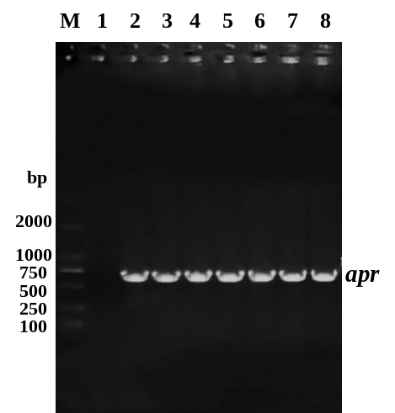
Figure S7. PCR analysis of apramycin (ap^{r}) gene from recombinant strains S. diastatochromogenes 1628-NA_{sr}. DL DNA 2000 marker was used (M). Lane 1: PCR product of ap^{r} gene from S. diastatochromogenes 1628; lane 2-8: PCR product of ap^{r} gene from recombinant strains S. diastatochromogenes 1628-NA_{sr}.

